**ANALOG INTEGRATED CIRCUIT PROJECT**

**LAYOUT DESIGN AND SIMULATION OF COMPARATOR CIRCUIT USING VLSI TOOL: MAGIC AND OrCAD PSPICE.**

**INTRODUCTION:**

The following project contains the simulation and layout design results of a comparator circuit. The comparator circuit is a collective circuit made with the help of four units: Differential amplifier, current mirror, CS Amplifier, and Inverter buffer.

**COMPARATOR CIRCUIT WITH MOSFETS (NMOS AND PMOS).**

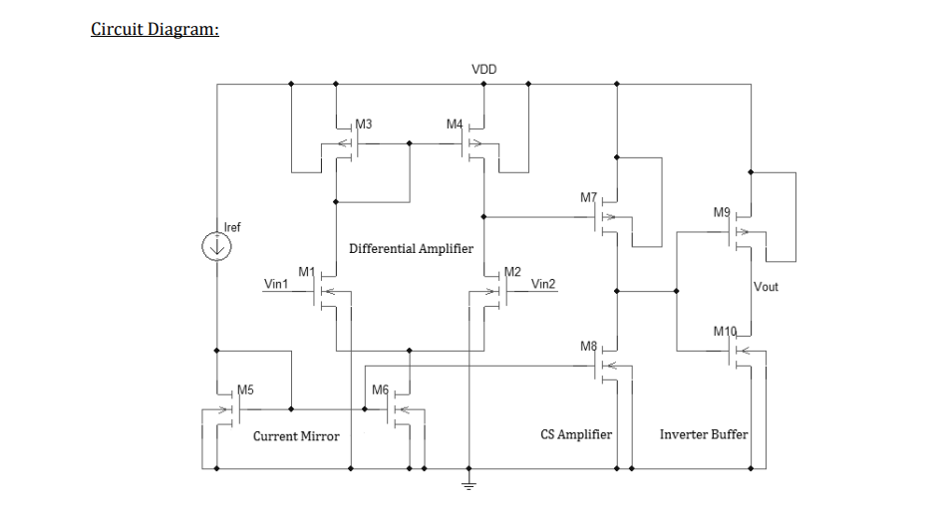

**THEORY:**

**COMPARATOR OPERATION:**

A comparator circuit compares two voltages and outputs either a 1 (the voltage at the plus side; VDD in the illustration) or a 0 (the voltage at the negative side) to indicate which is larger. Comparators are often used, for example, to check whether an input has reached some predetermined value. In most cases a comparator is implemented using a dedicated comparator IC.

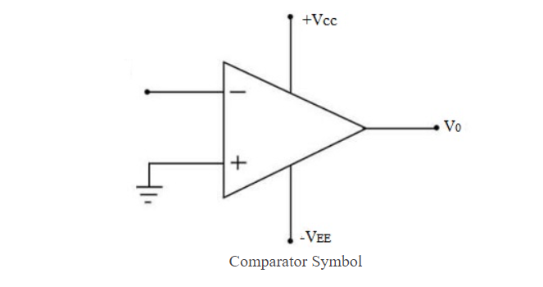

The comparator can be adjusted to provide a very small-time delay, but its frequency response characteristics will be limited. To avoid output oscillation, many comparators also have internal hysteresis circuits. The threshold of the comparator is fixed, some have only one threshold, and some have two thresholds.

**BUILDING BLOCKS:**

Two major circuits are evaluated

**1. Differential Amplifier**

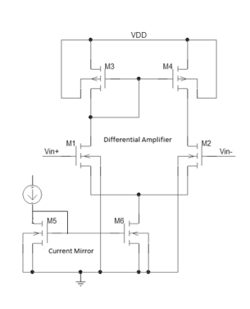

The differential amplifier amplifies the voltage difference present on its inverting and non-inverting inputs. The general topology of a differential amplifier is shown below. Two active devices are connected to a positive voltage supply via passive series elements.

If the input signals are designated v1 and v2, they can be decomposed into two linear combinations, one called the differential mode, and the other the common mode. The differential mode is defined by the following equation:

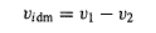

Similarly, the common mode, equal to the average value of the signals, is defined by

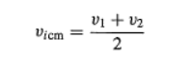

**2. Current Mirror (Source/Sink):**

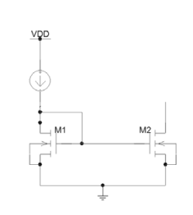

The common-mode gain of the differential amplifier will be small (desirable) if the small-signal Norton, resistance Rn of the biasing current source is large. As we have discussed in class, the biasing current source is not a naturally occurring element but must be synthesized from other transistors. In most situations, the designer will choose some form of the current mirror to produce the equivalent current source. The circuit on the left, shown below, is equivalent in all respects to the symbolic current-source component on the right.

In the current mirror circuit shown on the left, the reference current is set by the resistor. The voltage across the latter is given by the voltage drop across. Because the two MOSFETs are matched and have precisely the same gate-source and threshold voltages (VGSA = VGSB), their drain currents will be equal. Thus, the current Io becomes a replica, or "mirror image" of the reference current. If QB remains in its constant current region, then this replication will take place. Note that QA automatically operates in its constant current region, because its gate is connected to its drain. The Norton resistance rn the current source will be equal to the output resistance Ro of QB, as determined by the upward slope of that transistor's voltage-current characteristic. The latter is associated with the Early voltage, as discussed in class and in the text.

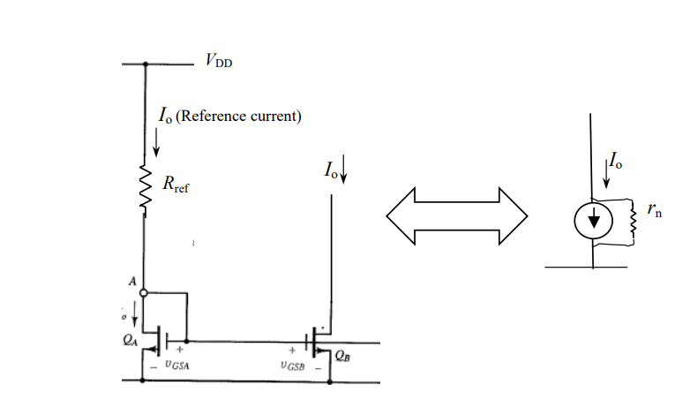

**OTHER BLOCKS:**

**1.CS AMPLIFIER:**

The common source circuit provides medium input and output impedance levels. Both current and voltage gain can be described as medium, but the output is the inverse of the input i.e., 180° phase change. This provides good overall performance and as such, it is often thought of as the most widely used configuration.

**2.INVERTER BUFFER:**

A CMOS inverter contains a PMOS and an NMOS transistor connected at the drain and gate terminals, a supply voltage VDD at the PMOS source terminal, and a ground connection at the NMOS source terminal ere VIN is connected to the gate terminals and VOUT is connected to the drain terminals. (See diagram). It is important to notice that the CMOS does not contain any resistors, which makes it more power-efficient than a regular resistor-MOSFET inverter. As the voltage at the input of the CMOS device varies between 0 and 5 volts, the state of the NMOS and PMOS varies accordingly. If we model each transistor as a simple switch activated by VIN, the inverter’s operations can be seen very easily:

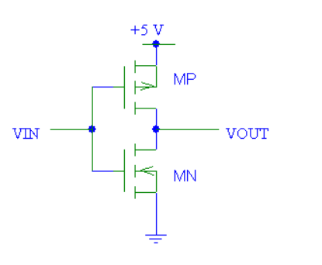

**THEORETICAL ANALYSIS AND HAND CALCULATIONS:**

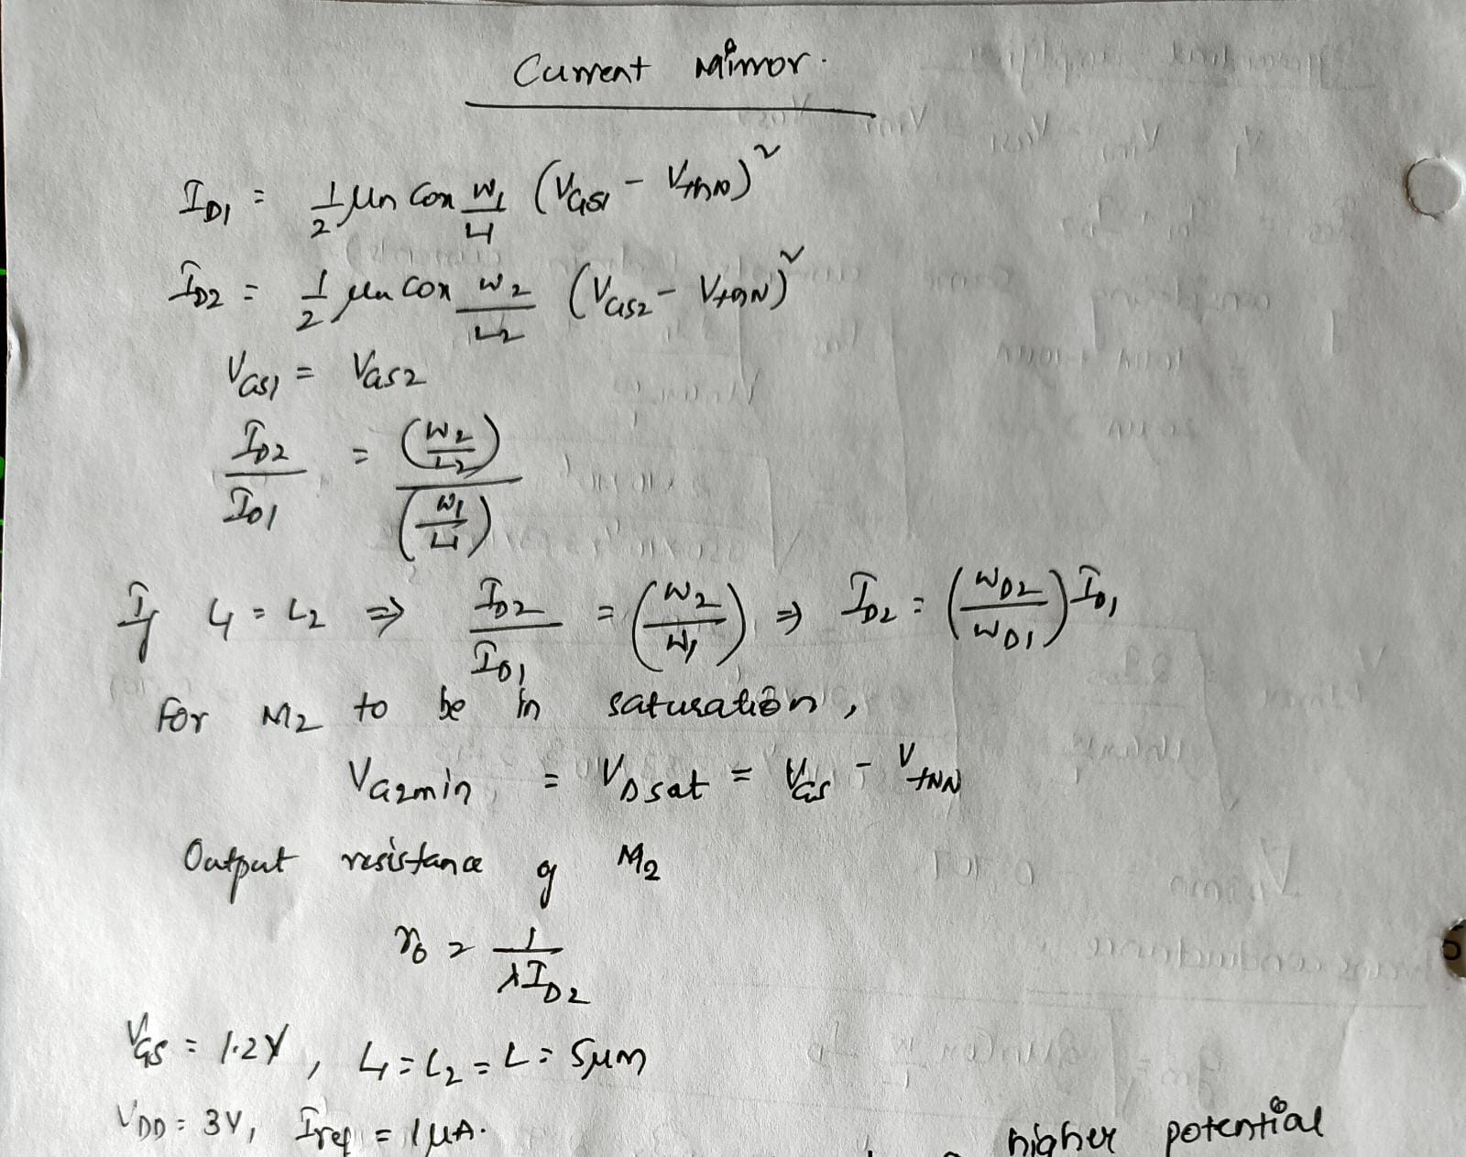

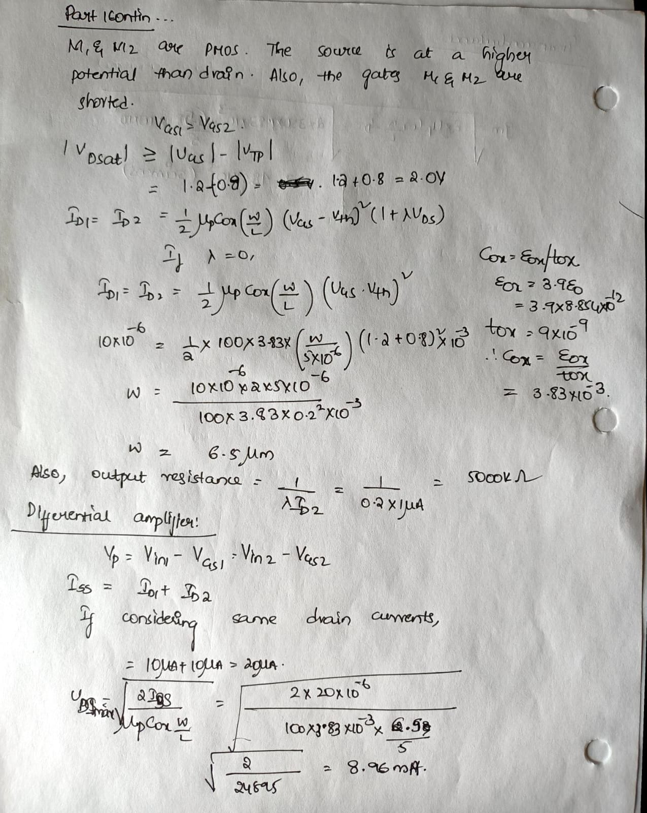

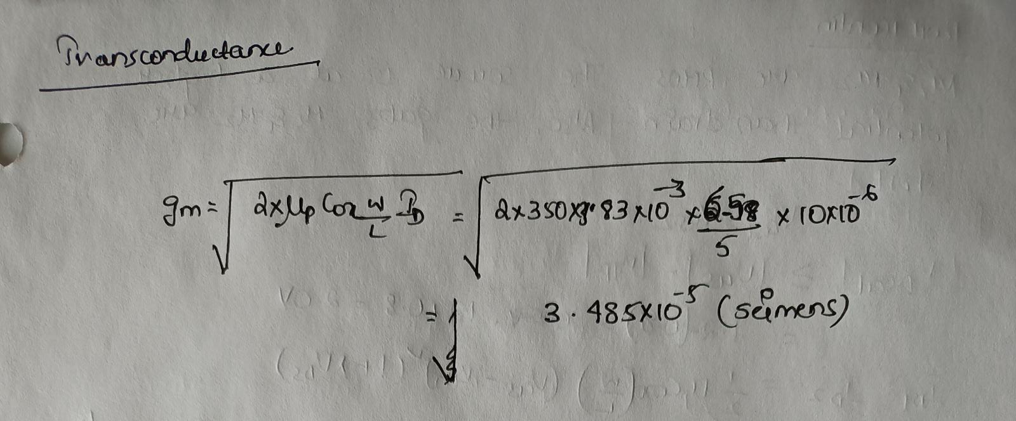

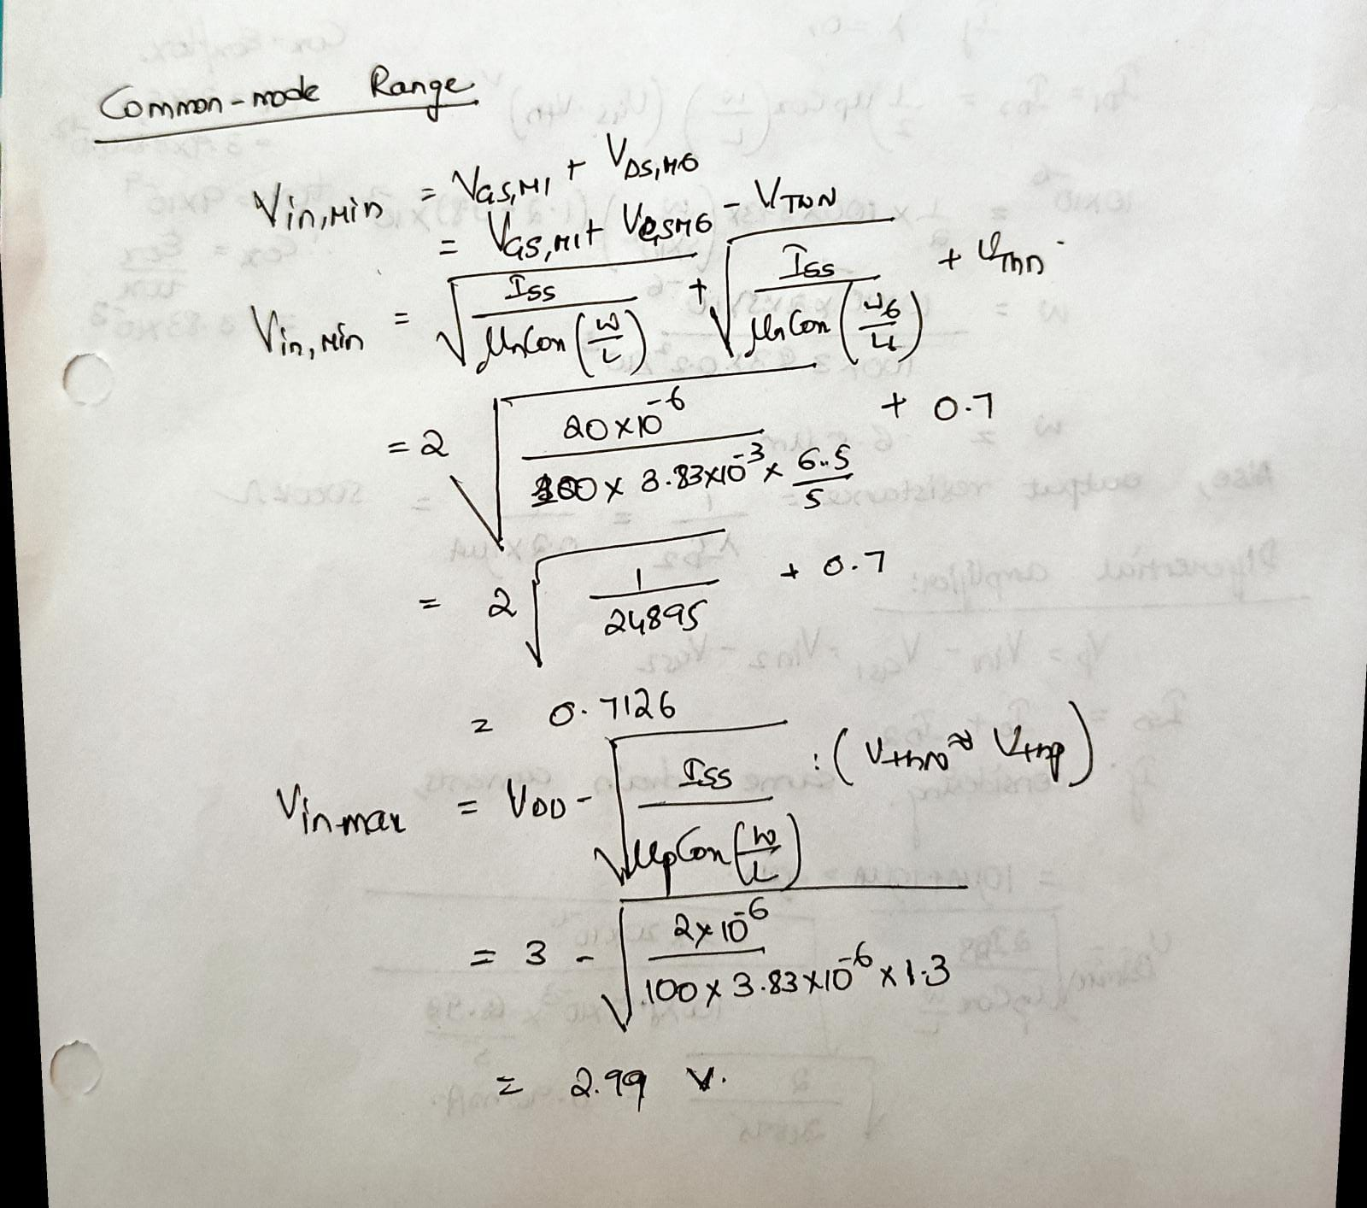

**SIMULATION RESULTS: The simulation has been performed using OrCAD Capture (Cadence)**

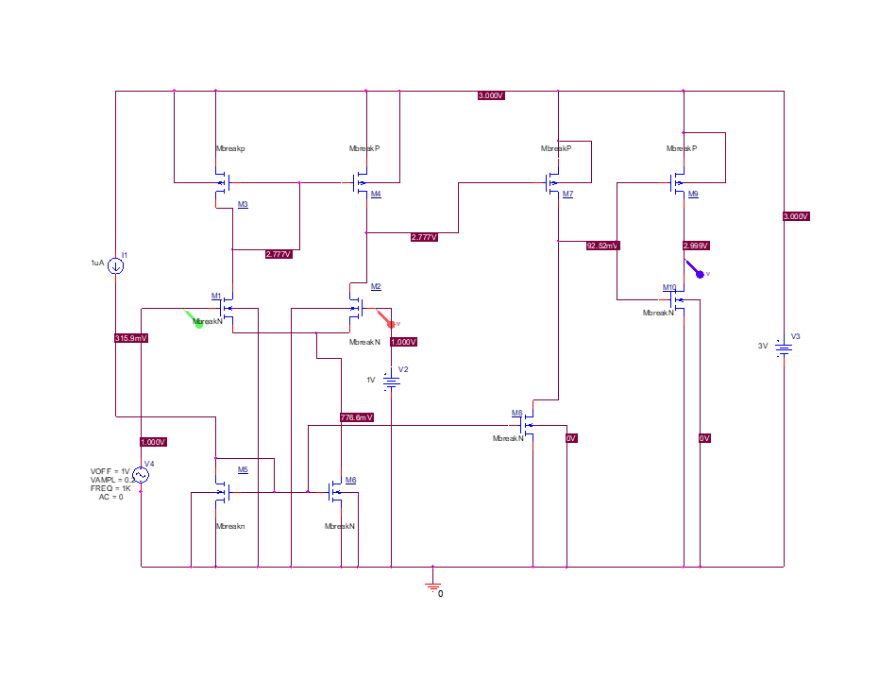

**PSPICE RESULTS:**

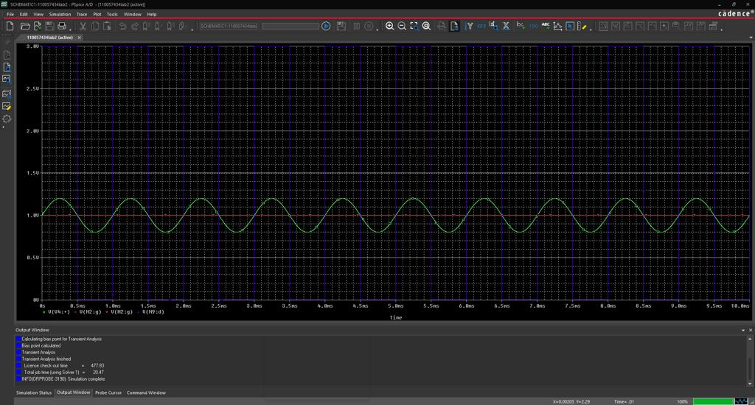

**MAGIC VLSI TOOL:**

**The layout has been done with the help of MAGIC VLSI Tool. Developed by the University of Berkley, the tool has applicable features of painting different layers using programming commands.**

**LAYOUT DESIGN RESULTS:**

